RUCHIKA PUROHIT

20MCA10005

Q. Watch some tutorials on any Unity topic and then write your own tutorial (text + screenshots) of that topic.

Ans: -

I have learnt how to create 3D objects in Unity through this tutorial.

Link of the tutorial: - <https://www.youtube.com/watch?v=D9qt1cTH2r0&list=PLGmYIROty-5bpzKQNK3mRMi4pmh_LinV4&index=2>

Introduction

In this tutorial is shows how to create 3D game objects in unity3D. Here, we will learn how to create more objects and how to create assets in unity3D, and we will also learn how to revert the object and apply it.

Steps: -

1.These are objects in unity: -

* Cube
* Sphere
* Capsule
* Cylinder
* Plane

2. Select the rotation tool, it helps to rotate your plane object. It also rotates all the objects in your game.

3.Create Assets Go to the hierarchy view, drag the cylinder and cube, and drop the ball option, cylinder, and cube in under the ball. You can move the ball, cylinder, and cube also.

4.We can revert the size and apply it on object.

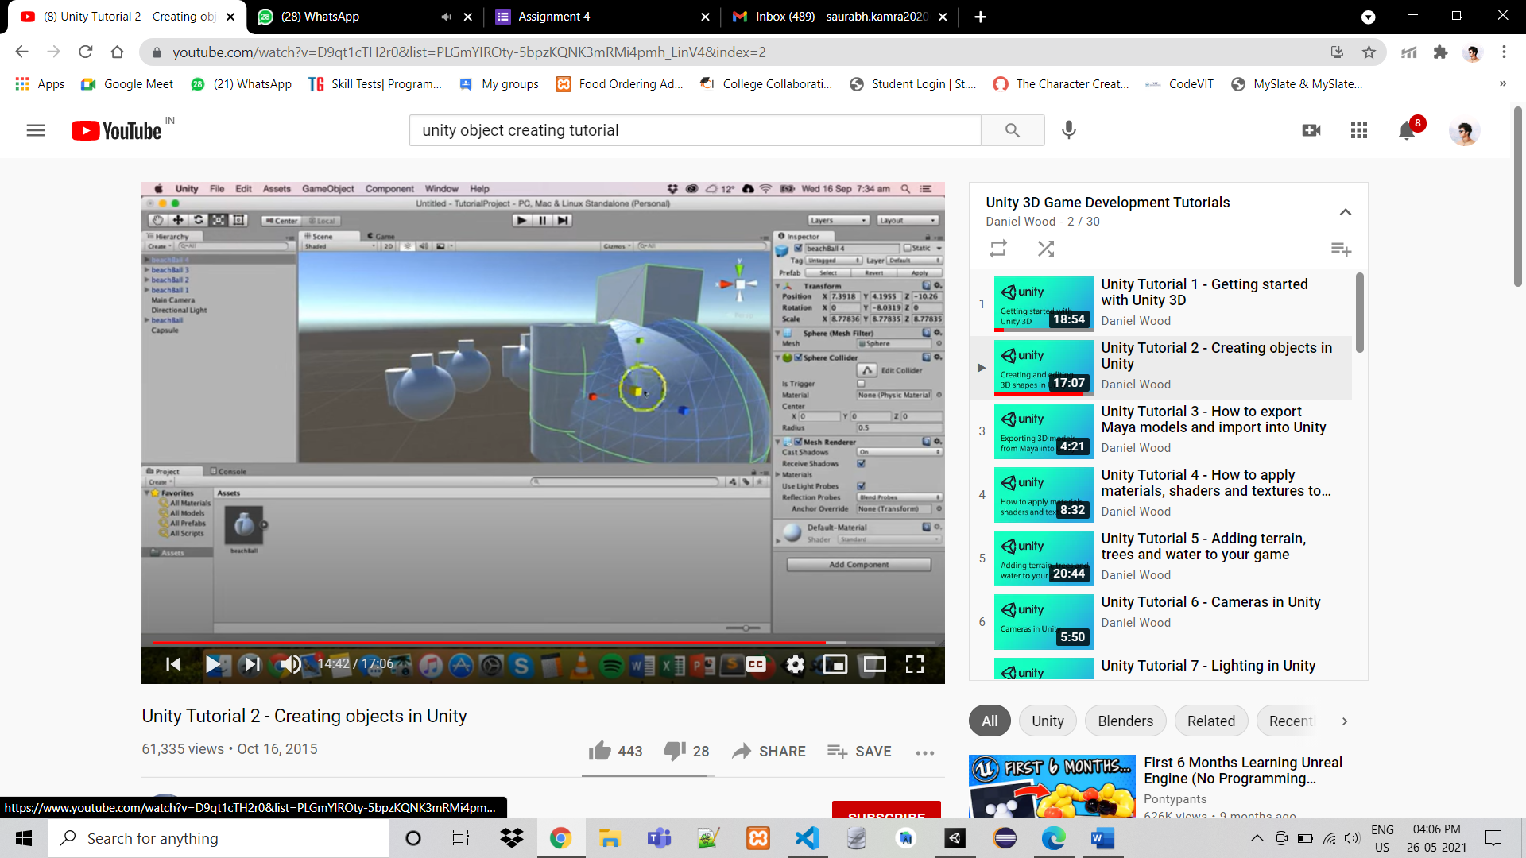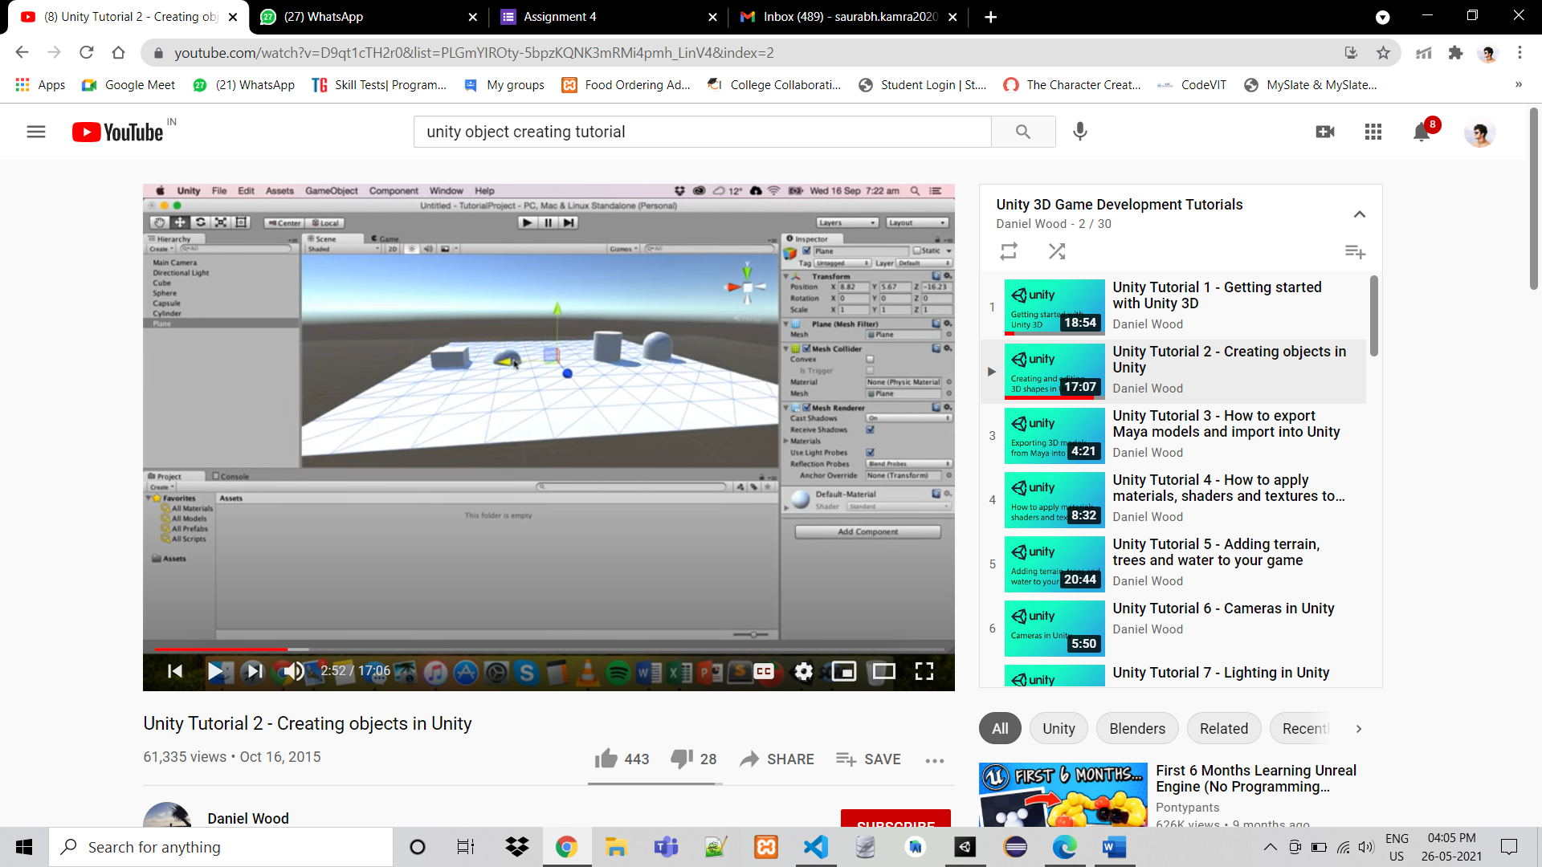

**MASKING**

Masks are images with alpha channel. An image with mask applied confirms the shape of that mask.

There are following reasons you want mask in your UI :-

* To prevent UI text components from going outside the bounds of the frame they are attached to.
* To crop large UI components to a smaller frame and allow the user to scroll and pan along it using a Scroll Rect component.

Steps to Apply Mask :-

Step 1

To create the Mask, First create a new UI image. You can do this by selecting **GameObject** > **UI** > **Image** from the top toolbar. This creates a new canvas GameObject with an image in its children. Rename the Image to *Mask.*

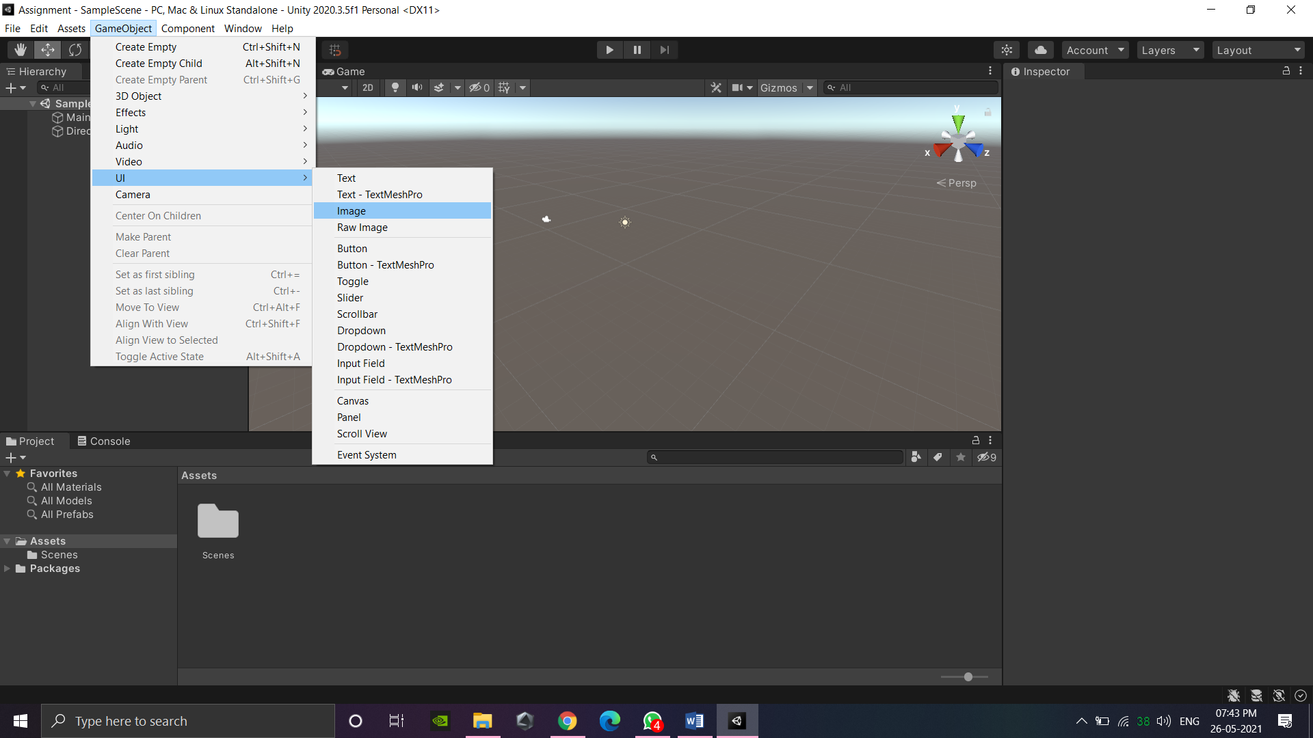

Step 2

Next, add a Mask component to the UI Image you just created. This can be done by selecting **Add Component** in the Inspector and choosing **UI** > **Mask**. (Marked On the Image)

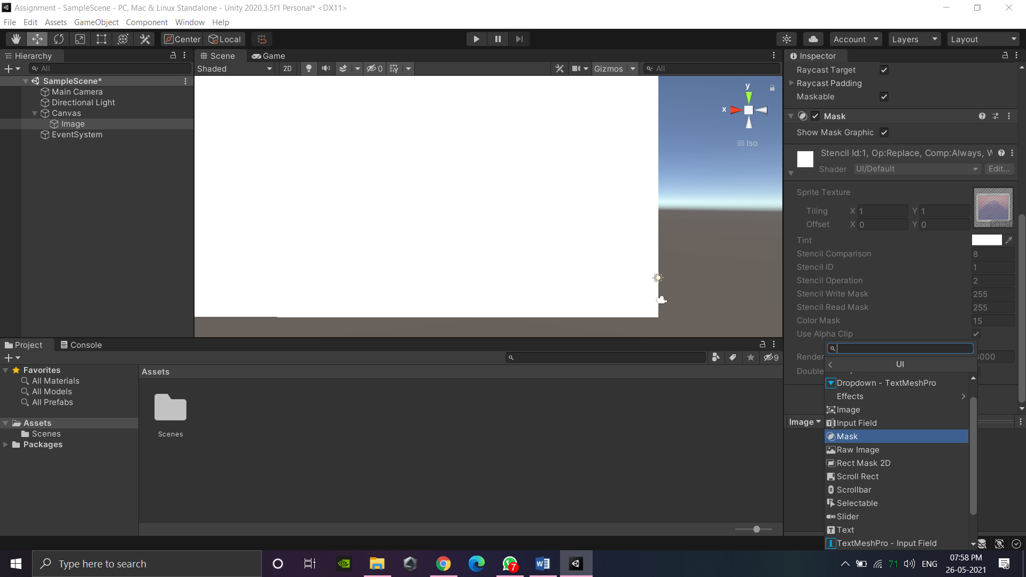

Step 3

Parent a Raw Image to this mask. Raw Images are less optimized, but necessary to display large, detailed images, such as unity logo. You can do this by selecting **GameObject** > **UI** > **Raw Image** from the top toolbar.

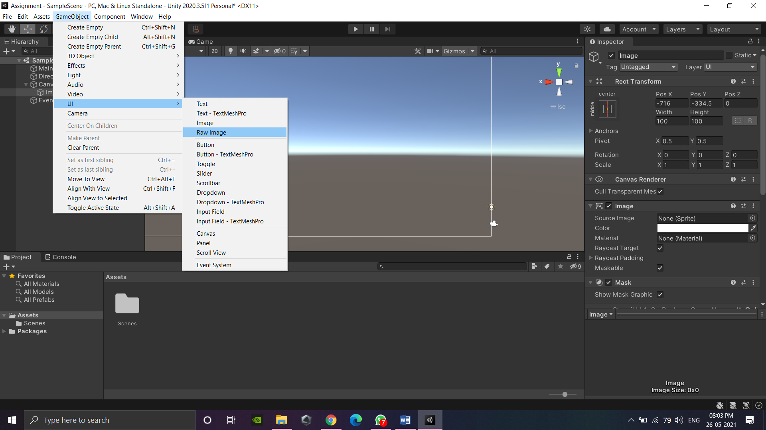

Step 4

In the Mask GameObject, select the Sprite to use for the Source Image. This will dictate the frame the Raw Image will conform to.

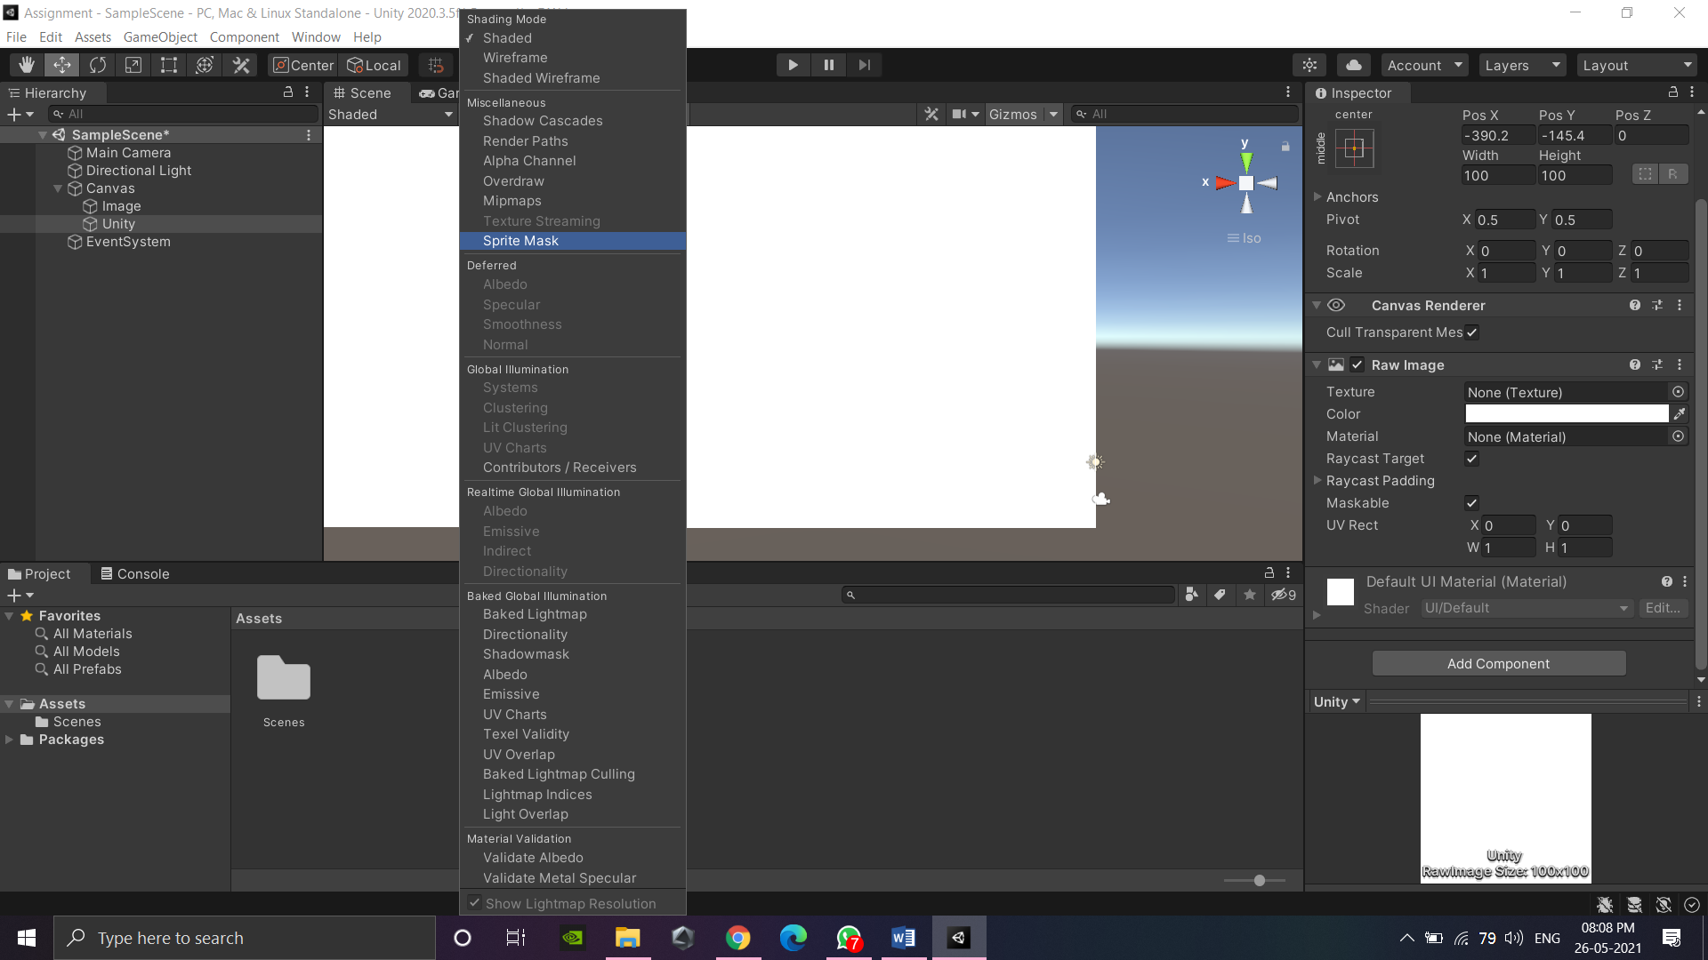

Step 5

Using the Mask’s RectTransform, adjust the position, width, and height as desired(Marked On The Image)

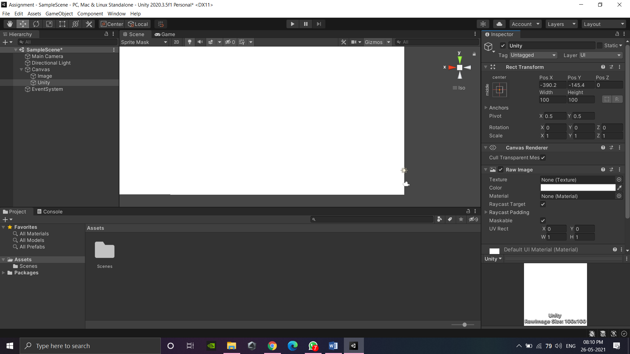

Step 4

The Raw Image will contain the component we wish to pan and scroll — in this case, the Unity logo. Set the Texture parameter to an image of your choosing.

Step 5

Next, add a Scroll Rect component to the Raw Image GameObject. We can leave the settings at default for now

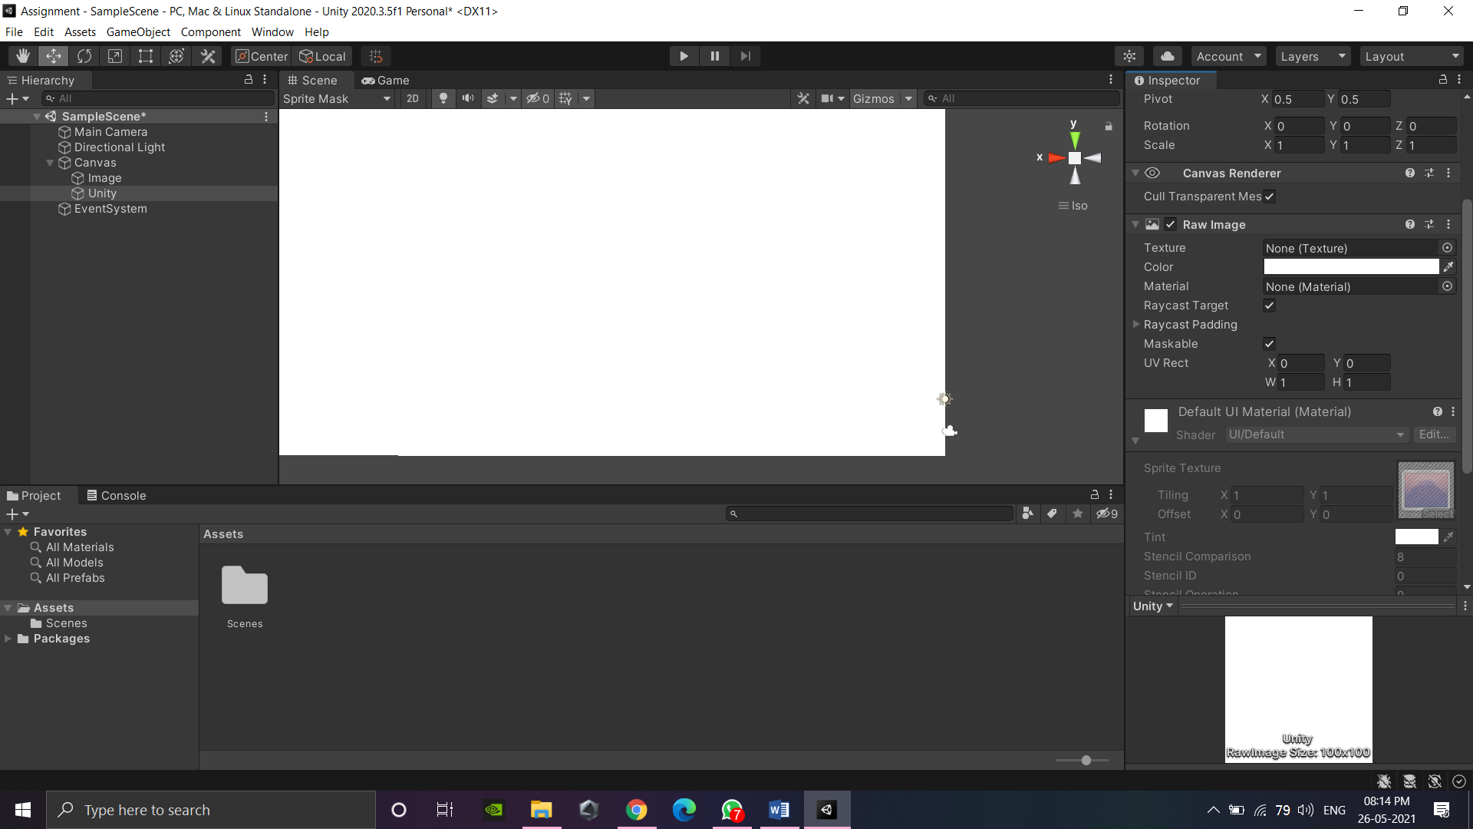

Step 6

Next to the Content parameter, select the Raw Image GameObject that this component is attached to.

Enter **Play Mode** and try manipulating the image with either your mouse or, if on a touch device, dragging a finger across it. You should be able to click and drag or swipe to pan the image along the mask we created.

